Year 6 Transition

Name: ________________________________________________________

Primary School: ________________________________________________

Secondary School: _____________________________________________

My New School

Draw a picture of your new school in the box above. Maybe you could be standing outside it!

When you know which School you are going to go to in September, it is a good idea to find out as much information as you can before you start.

The name of the School is __________________________________________________

The address is ___________________________________________________________

_______________________________________________________________________

The telephone number is ___________________________________________________

The e-mail address is ______________________________________________________

The website address is _____________________________________________________

The name of the head teacher is______________________________________________

Going to Secondary School

How do you feel?

These could be useful to think about when you think about changing school.

Use two different coloured highlighters, highlight the phrases that you are looking forward to in one colour; use a different colour for those you are worried about. Or cut them out and stick them into the boxes on the next page.

Making new friends | Learning a new timetable
Dinner time | Taking a shower
Having a different uniform | Being on time
Finding way around | Break times
Getting to school | Learning new subjects
Meeting others my own age | Joining clubs
Being with friends | School rules
Homework | Meeting my new tutor
Meeting my new teachers | Being able to do the work
Being with older pupils | Getting changed for sport / PE

If you have cut out the phrases from the previous page, paste them into the appropriate box.

Worries | Happy

A solution-focused approach

Think about something that worries you about moving to Secondary School.

0 1 2 3 4 5 6 7 8 9 10
OK Not OK

What is the worry? ________________________________________________________

_______________________________________________________________________

On the scale of 0 to 10 how worried are you? ___________________________________

Think of a time when you have been worried before ______________________________

_______________________________________________________________________

What helped you move down the scale that time? _______________________________

_______________________________________________________________________

Where on the scale would you like to feel in a month, 6 months and in a year? _________

_______________________________________________________________________

What would help you move one point nearer? ___________________________________

________________________________________________________________________

What will have changed so you know you are less worried? ________________________

________________________________________________________________________

Secondary School question sheet
Some of these questions might not be of interest to you and others you might have to wait a little while to find out. You might be able to find answers on the school website or from friends who attend the school. You DO NOT have t answer every question!

Questions about how the School works | Best way to find out | Answer
What time does School start/ finish?

What times are break-times and lunch time?

What sort of food is sold?
How much do things cost?

Where do students go at lunch time?

What snacks can you buy?

How much homework do you get?

What happens if it isn’t done?

Where can I do my homework in my free time?

What happens if I get into trouble? What are the punishments?
Who’s the best person to talk to if I am having problems?
How am I rewarded for my work?

Questions about getting to School | Best way to find out | Answer
Where is the School?

How will I get there?

Can I take a bike?
Where can I put it?

How much is the bus fare?
Which number bus would I take?
Are there friends who will be gong to the same college I can walk with?
How long will it take to get there?

What time will I have to get up?

Is this better or worse than now?

Questions about School Uniform and equipment | Best way to find out | Answer
What do people wear to School?

Where can I buy it?

What sports kit will I need?

Do I need my own pens and pencils?
What kind of bag will I take my School equipment in?

Is there any other equipment that I need?

Questions about the timetable and learning opportunities in School | Best way to find out | Answer
How does the timetable work?

What subjects will I be able to study?

What facilities does the School have (e.g. sports equipment, science laboratories)?
What happens if I find the work hard?

Is there support in lessons?

Does it offer anything after school?

What other activities are offered?

Which could I join?

Any other questions I have | Best way to find out | Answer
1.

2.

3.

4.

5.

Finding your way around

At first it can be daunting trying to find your way around a new environment. Before you visit the Secondary School, see if you can get a map of it. Mark on rooms in different colours.

You may want to mark on

- Your form room
- The library
- Different subject rooms e.g. English room, Science labs, Art room, Computer suite
- The canteen
- The toilets
- The main office
- Student’s entrance

School Staff

There are many teachers in a secondary school, not all of them will teach you, but may be important to you in a different way. As well as being a teacher they may have another job in school. The different names for these jobs are helpful to learn.

Written below are some of the jobs that adults in your secondary school may have.

Try and find out if there are adults in your secondary school who do this job, what they do and when you may see them.

The name of your form tutor_______________________________________
What do they do? _______________________________________________
When may you see them? ________________________________________

The name of the Head of Year 7 ___________________________________
What do they do? _______________________________________________
When may you see them? ________________________________________

Is there anyone else who might help you?

What is their name? _____________________________________________
What do they do? _______________________________________________
When may you see them? ________________________________________

School Uniform

It is important to wear the right clothes when you start at Secondary School.

Find some photographs of students at school. You may find pictures on the website, in the school prospectus or you may know someone who already goes to the school who can show you.

Find out the school dress code.
Are there any clothes or jewellery you are not allowed to wear?

________________________________________________________________________

________________________________________________________________________

Is there anything you need to practice?
- Tying a tie?
- Changing quickly for PE?
- Tying shoelaces?

________________________________________________________________________

________________________________________________________________________

List some of the clothes you might wear to school. Remember to think about appropriate shoes.

1. ______________________________________________________________________

2. ______________________________________________________________________

3. ______________________________________________________________________

4. ______________________________________________________________________

5. ______________________________________________________________________

My school uniform or dress code

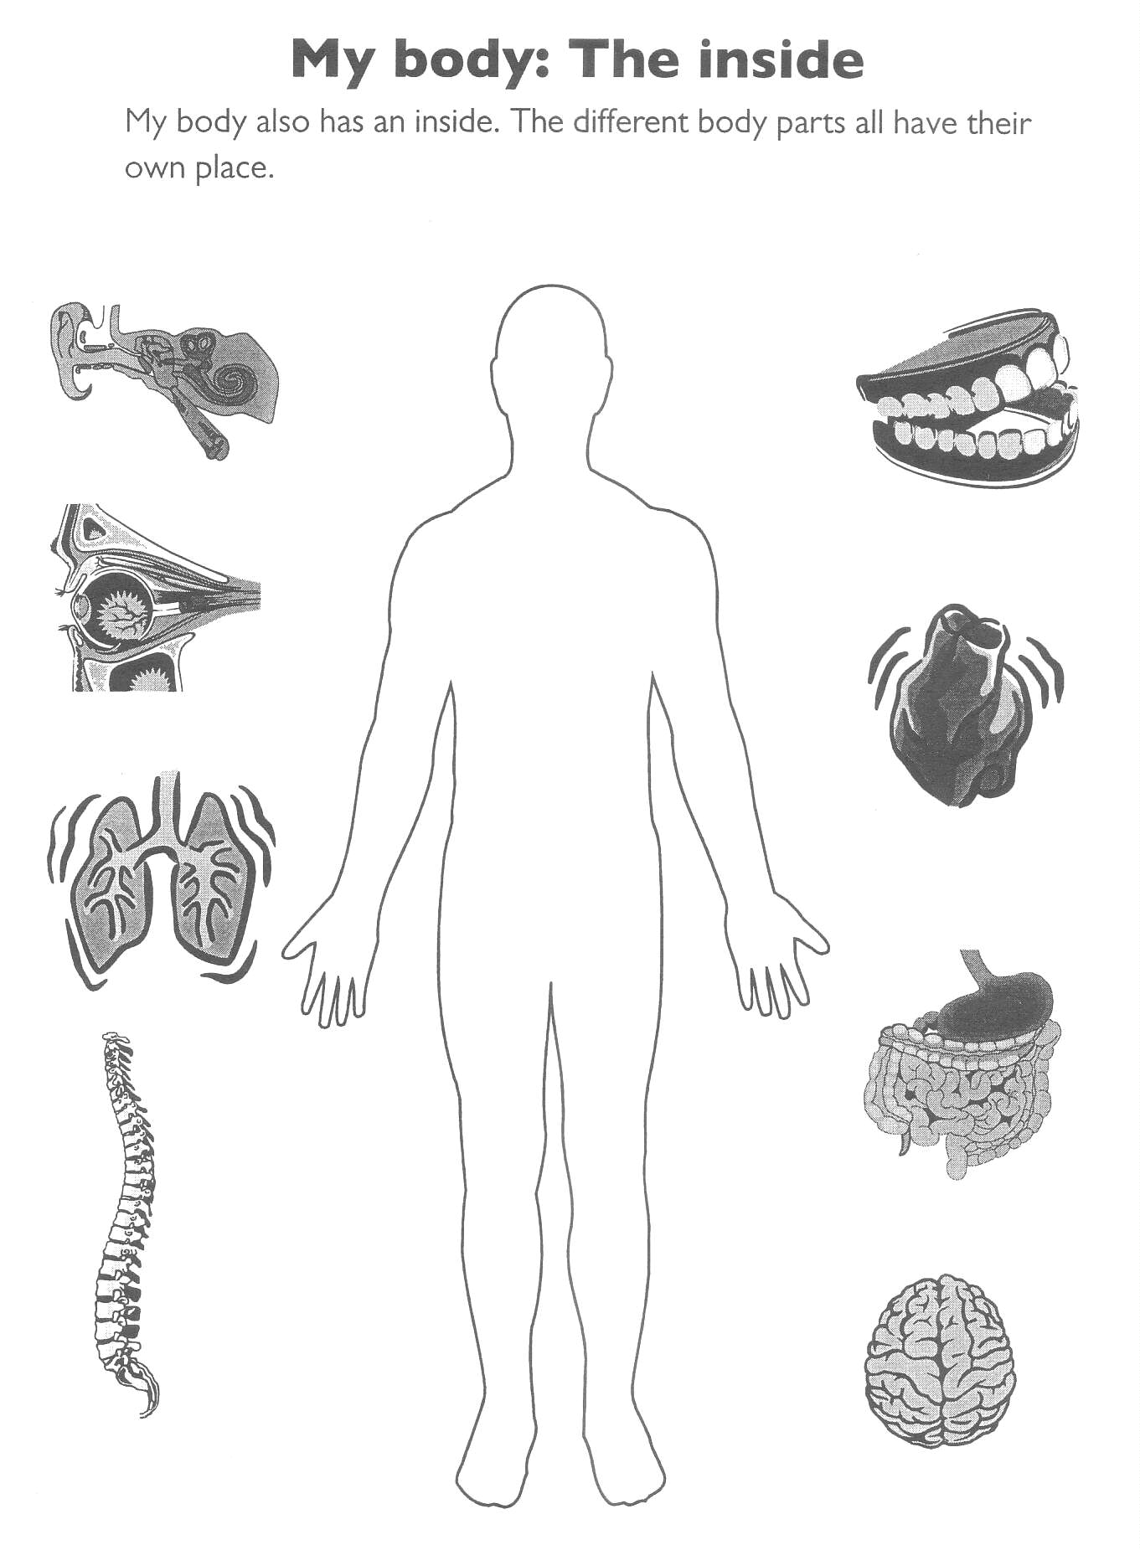

Organisation at school
8
7
10
11
9
5
4
1
2
6
12

Lunch time is at:
_ _: _ _

3
8
7
10
11
9
5
4
1
2
6
12

School starts at:
_ _: _ _

3
8
7
10
11
9
5
4
1
2
6
12

Break time is at:
_ _: _ _

3
8
7
10
11
9
5
4
1
2
6
12

School finishes at:
_ _: _ _

3
School times

School times

Morning Break

At the end of a lesson you need to pack your bag, check you have all your belongings and usually you have to leave the room in order to go to your next lesson. At some time in the morning you will usually have a longer break in which you have time for a snack and to meet up with your friends.

Finish
Start
Length of break

Where can I go and what can I do at morning break?

Place | What you are allowed to do

What snacks could I buy at School?

1. _____________________________

2. _____________________________

3. _____________________________

Lunch Break

The lunch break is between morning and afternoon lessons. It is a time when you can mix with your friends, go to a lunchtime activity, and eat your lunch.

Finish
Start
Length of break

Where can I go and what can I do at lunchtime?

Most Secondary Schools have a canteen system or you can bring a packed lunch.

Make a list of some of the different types of food you can buy in the canteen:

1. _____________________________

2. _____________________________

3. _____________________________

REMEMBER you might need to bring in money or a card / voucher (eg: a “Smartcard”)

If you bring in a packed lunch you will need to find out

Where can you eat it? ______________________________________________________

What time do you eat it? ____________________________________________________

What sort of drinks or containers
are you allowed to bring into school? __________________________________________
Lunch time activities- there are often different activities that occur at lunchtime

Make a list of the different activities you could do:

1. _________________________________

2. _________________________________

3. _________________________________

4. _________________________________

5. _________________________________

Places to go- there are often different places you can go during your lunch break

Place | What you are allowed to do

Coping in Secondary School

Think about how you are expected to behave in School and the reasons for this.

Fill in the chart below. If you cannot think of some reasons there are some suggestions below.

School expectations | Positive results if I do the things in column 1 | Possible negative results if I do not do the things in column 1
Attend classes

Work hard

Produce work on time

Co-operate with others

Get a good qualification and a good recommendation from School

These are some positive and negative statements to help you.

People will think I am productive.
Other students may ask for my help.

Tutors and family will be concerned that I am not achieving my full potential.

People will think I am conscientious,
I will feel satisfied with my studies.

Tutors will be concerned if I disrupt the group and stop other students from working. People who disrupt other students’ work are often asked to leave the school.

I am likely to get an interesting and rewarding job. I will feel happy.

Tutors and family will worry about me. Tutors will not be able to their job of teaching and helping me.

People will think I am reliable.
I will feel good.

I am unlikely to get a good qualification and so will have less employment choices available to me. I may not earn enough money to pursue my interests.

People will think I am good to work with.

Tutors and family will worry about me. They may feel I am not taking full responsibility for my work, and not asking for help when it is needed.

Morning routine

Before leaving for School there are a lot of things to think about, starting from the night before.

Things to think about in the morning. Put them in the right order.

- Get dressed
- Check you have the correct equipment in your bag
- Check your timetable
- Wash
- Check you have got your homework
- Clean your teeth
- Say “Goodbye”
- Check you have the correct money
- Wake up
- Eat your breakfast
- Leave for School
Any others?
- _______________________
- _______________________
Plan your morning routine with approximate times.

Time | What to do

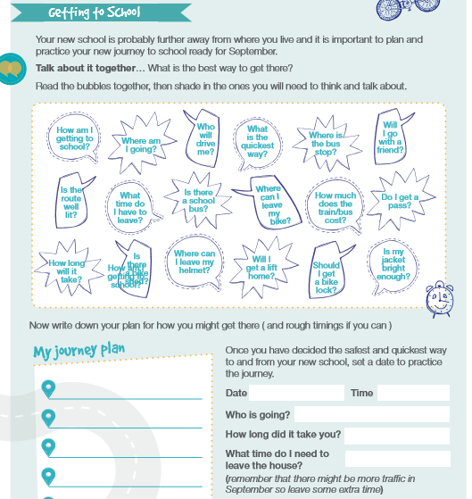

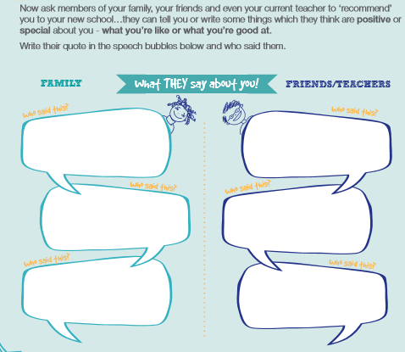

School equipment

Things I need to bring every day

Every day you will need your writing equipment. Circle the equipment you need in your pencil case. Draw in anything else you need.



Some days you will need extra equipment. This will depend on the lessons you have that day. Look at your timetable and work out the additional equipment you need each day.

Day | Things I will need to bring
Monday

Tuesday

Wednesday

Thursday

Friday

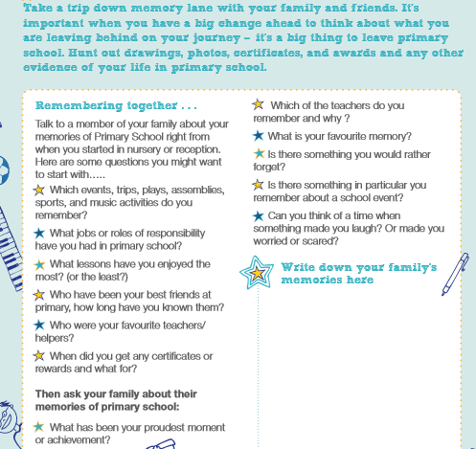

Getting to know you

My favourite place is…………………………………………………………………………………

My favourite food is……………………………………………………….……………………..…..

My interests are…….……………………………………………………………………………….

I don’t like……………………………………………………………………………………………

I like to listen to …………………………………………………………………………………….

My favourite band/music is………………………………………………………………………...

My favourite sport is………………………………………………………………………………..

My favourite programme is………………………………………………………………………..

My favourite colour is…………………………………………………………..............................

I like to wear …………………………………………………………………………………………

I am looking forward to ……………………………………………………………………………..

I am most relaxed when…………………………………………………………………………….

I worry about…………………………………………………………………………......................

I am happiest when…………………………………………………………………………………

I get angry when……………………………………………………………………………………..

Joining-in

Joining in conversation or a group activity can be scary. However, it is one way to make new friends. Try these strategies for joining in.

Watch and listen. Observe what the group is doing. Listen to what the people are saying. Don’t interrupt.


Make a friendly comment or gesture. Nod your head and smile. Make comments like, “That’s a good idea”, or “That looks great”.

Find something you have in common with the group. Think about your own experiences. You could say, “I saw that movie”, or “ I have that game at home”. Keep your comments short.

Ask to join the group. Wait for a pause in the conversation. You could say, “Can I walk with you?” “Do you need any help?” or “Can I play?”

Accept ‘no’ for an answer. Sometimes people don’t want you to be part of the group. Don’t argue or complain. Go and ask someone else.

Joining-in Situations

Here are some situations you might want to join in with. Try and plan what you may say or do. You could try acting these situations out.

- You see three of your classmates playing football after school. You know one of them pretty well. You don’t know the other two. You’re quite good at being in goal.

What could you do?____________________________

What could you say?___________________________

- You hear two classmates talking about the latest playstation game. You were playing on it last night.

What could you do?___________________________________

What could you say?__________________________________

- Two classmates you know are gathered around a phone. A third classmate is calling a local radio station to try to win a contest. You think you may know the answer.

What could you do?___________________________________

What could you say?__________________________________

- Four classmates are looking at a whatsapp message they have received from a friend. They are laughing. You’re sitting at the same lunch table.

What could you do?__________________________________

What could you say?_________________________________

- Two classmates are asking the teacher for permission to work on an art project during lunch hour. Art is your best subject and your project is already on display.

What could you do?___________________________________

What could you say?__________________________________

Being with friends

Sometimes you have to think carefully about how you act with different people and whom you can share information with.

Using the concentric circles sheet, work out who you would act in these ways with. You may choose more than one group of people.

- Who would you hug?

- Who could you tell what to do?

- Who can you argue with?

- Who can you share your sweets with?

Make up your own: ________________________________________________________

________________________________________________________________________

Sharing information about yourself
It is important to talk to people to share an event, achievement or tell them about a problem. Sometimes you have to consider whom you talk to. Some people may tease you if you are not good friends or they may not keep the information to themselves and share it with others.

Who would you tell these things to? Use the concentric circles to decide who you would share the information with.

- You still cuddle your teddy at night.

- You fancy the girl or boy next door.

- You have won a competition.

- You have not done your homework.

- You hate peas.

Make up your own: ________________________________________________________

________________________________________________________________________

Concentric Circles

Anyone
Teacher
Friend
Family
No
one
Facts about bullying

Bullying:

- Is any behaviour by an individual or a group that deliberately harms another.

- Can be physical or involve threats of physical harm.

- Can be name-calling or spoken teasing.

- Can be demanding money of things, or making someone do something they do not want to do.

- Can involve excluding someone (deliberately leaving someone out of an activity, ignoring them etc.)

- Is usually repeated over a period of time.

- Takes place when one person or group has more power than the person or group being bullied.

Bullying is not:

- An accidental bump or jostle, in the school corridor, for example.

- An argument with a friend.

- A friend being nasty over something specific.

- A one-off fight or argument.

Why do people bully?

- Very few people who are happy with themselves bully others

- Sometimes bullies have been bullied themselves - they are looking for someone to take their anger out on.

- Sometimes bullies are jealous.

- Bullying can make people feel strong, respected and powerful, but they often feel bad too.

What to do about bullying

What can you do if you are bullied?

- Don’t keep it to yourself: Always tell someone- a teacher, a parent or another adult.
- Keep being positive; say positive things about yourself and other people.

- Be proud of who and what you are (we all belong to different groups and are all equally valuable).

Reasons to tell:

- You have the right to live without the stress or fear of being bullied.

- Taking action is better than doing nothing.

- Bullying does not say anything about YOU. It says a lot about the BULLY. Telling someone might actually even help the bully as well as you!

Asking for help

Sometimes at school things may be difficult or may go wrong. These things could be small:
  - not knowing what the homework is
  - not being able to find your way around

Or could be bigger:
  - getting into trouble
  - finding the work hard.

There are many people who could help you, but they won’t know that you need help unless you tell them.

Friends Ask friends or other students if you don’t know where to go. You can ask them what the homework was if you are not certain. They can also help to work out new situations like going to the cafeteria.

Teachers Ask your teachers if you don’t know what to do in class or for homework. They will also be able to help you if you have forgotten something or don’t know where to go.

People at home People at home will be able to help you plan and organise your equipment and homework. They will want to know if you have any problems. They will be able to help you work out the best person to ask if you have problems with work or may try and contact someone in school and ask them to help you.

Try and work out whom you would approach in these situations:

- You don’t know where your next lesson is.

- You cannot read your homework notes.

- You have got into trouble for forgetting your course book several times.

- In the lesson you did not understand what the teacher wanted you to do.

- You have not got a pencil which is needed to complete your work.

REMEMBER TO ASK FOR HELP!

Settling into Secondary School
(and how to solve the problems you might face)

Sometimes something can happen at school that makes you upset or anxious. A lot of people feel like this especially when they are starting somewhere new.

- Keep calm. Tell yourself, “I can solve this problem if I stay calm.”

- Decide what the problem is.
- Are you frustrated because you could not do something you wanted?
- Are you upset because someone did something to you?
- Are you worried because something has gone wrong?

- Think about possible solutions.

- Think about the consequences. What will happen if you try different solutions?

- Pick the best solution.

Talk with a friend about what you would do in each of these situations in school.

1. You haven’t done your homework.
2. You have forgotten your student planner.
3. You are in a crowd going upstairs and you think someone pushed you.
4. You think you are lost.
5. You see someone being bullied.
6. You find someone crying in the corridor.
7. You’ve lost your purse/ wallet.
8. You see someone stealing money from someone’s bag.
9. You find someone’s purse.
10. You’ve ripped your trousers/ skirt.

